1. mean tree diameter (mDBH.cm) versus plot biomass (AGBH.Mg.ha)

1.1 Null and alternative hypotheses of your tests

**H0**: mean tree diameter has no effect on biomass

Ha: mean tree diameter is related to biomass

1.2 Results of your statistical test, interpreting your test in 2-3 sentences that

include the appropriate reporting of the statistics

**C**orrelation test reports a 0.6669992 correlation of mean tree diameter and plot biomass, which means there is a positive relationship between these two variables; the data point with highest tree diameter seems to have a large effect on the correlation coefficient, the new correlation after eliminating is 0.6837709.

1.3 An interpretation of the regression model (equation) from each analysis

**A**verage tree diameter in forest plots significantly increases plot-level biomass, with a 1 cm increase in average tree diameter resulting in a 25.35 Mg/ha increase in plot biomass (R2 = 0.4371, F1, 71 = 56.9, p < 0.001).

1.4 A description of how you checked the assumptions of your statistical test

**I** checked the assumptions by plotting of the model, which provides four diagnostic plots.

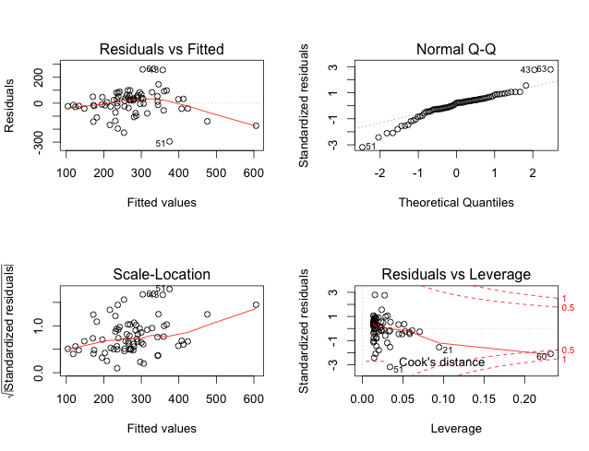

1.5 An interpretation of diagnostic figures

**I** looked at first plot and third one to check the assumption homoscedasticity and linearity; second to check the assumption of normality; and the fourth to look for any trouble points that have relatively large effect on coefficients of the linear model. Overall the data seem to fit the assumption except for a few points.

2. mean height (mH.m) versus mean wood density (mWD.g.m3).

2.1 Null and alternative hypotheses of your tests

**H0**: mean wood density has no effect on mean height

Ha: mean wood density is related to mean height

2.2 Results of your statistical test, interpreting your test in 2-3 sentences that

include the appropriate reporting of the statistics

**C**orrelation test reports a 0.4886336 correlation of mean wood density and mean height, which means there is a positive relationship between these two variables; the data point with highest mean height seems to have a large effect on the correlation coefficient, the new correlation after eliminating is reduced to 0.3243772.

2.3 An interpretation of the regression model (equation) from each analysis

**M**ean wood density in forest plots significantly increases mean height, with a 1 increase in g per m3 resulting in a 11.242 increase in mean height (R2 = 0.228, F1, 71 = 22.27, p < 0.001).

2.4 A description of how you checked the assumptions of your statistical test

**I** checked the assumptions by plotting of the model, which provides four diagnostic plots.

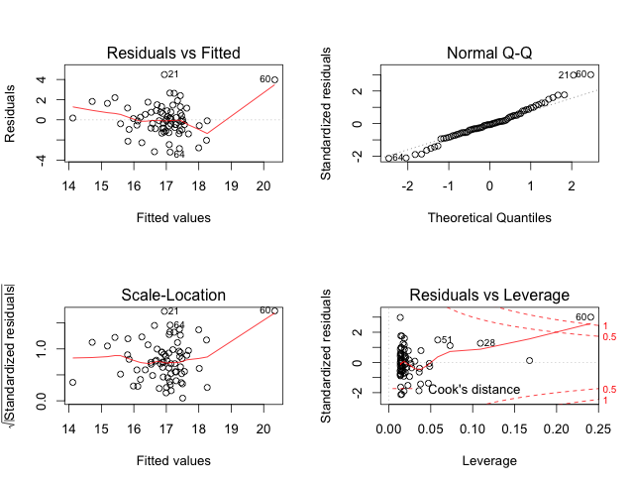

If we eliminate the effect of point 60, the data seems to fit the assumptions better:

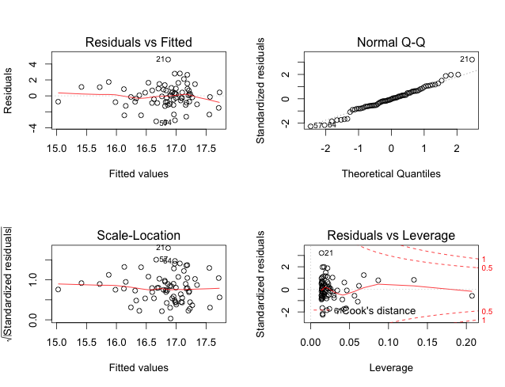

1.5 An interpretation of diagnostic figures

**I** looked at first plot and third one to check the assumption homoscedasticity and linearity; second to check the assumption of normality; and the fourth to look for any trouble points that have relatively large effect on coefficients of the linear model. Point 60 seems an outlier according to the diagnostic plots.